Dinosaur-era mammals’ fur color revealed for first time
Preserved pigments suggest Jurassic mammals had dark fur, consistent with a nocturnal lifestyle
13 MAR 20252:00 PM ETBYRODRIGO PÉREZ ORTEGA
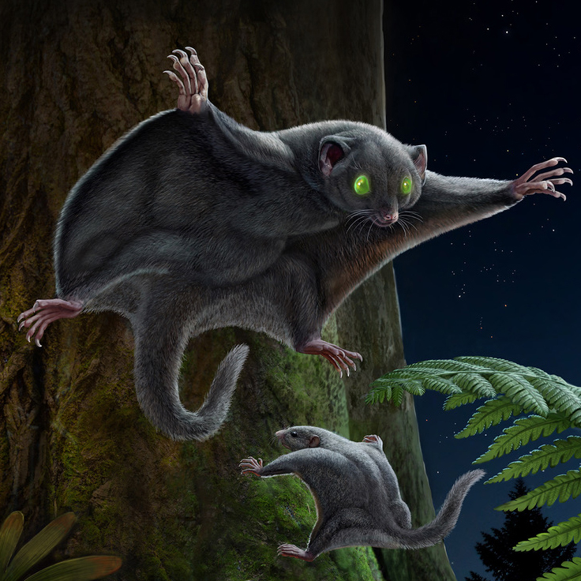
Researchers have long known that many dinosaurs had bold patterns and bright, sometimes flashy feathers—far from the grayish, scaly monsters we often see in movies. Now, a new study of Chinese fossils published today in Science reveals the coloration of some of the early mammals that coexisted with dinosaurs. They were clad in dark brown or grayish fur—a trait that may have played a key role in their survival up to the present.

The new finding also reinforces the idea that “mammals were living in the shadow of the dinosaurs, quite literally” and likely lived nocturnal lifestyles to avoid unwanted attention, says Jasmina Wiemann, a molecular paleobiologist at Johns Hopkins University who was not involved in the new work.

This is not the first time researchers have searched for color in the fossil record, which can shed light on how ancient creatures camouflaged themselves, jockeyed for social status, or signaled to potential mates. To reconstruct the color of ancient creatures, researchers look for fossils that preserve melanosomes: the intracellular structures in living animals’ skin, feathers, and fur that contain the pigment melanin. So far, melanosomes have revealed coloration and patterning in dinosaurs, early birds, and pterosaurs. However, few mammal fossils had undergone similar study, in part because similarly exquisite mammal fossils have been found only in the past decade or so.

To see what mammals from the Mesozoic era looked like, researchers led by Matthew Shawkey—an evolutionary biologist at the University of Ghent—first created a database of the hair color and melanosome structures of 116 modern mammals including monkeys, bats, and cats—including Shawkey’s own, Masha. The researchers then used this database to develop a model that predicted hair color from melanosome shape. Across all species, a melanosome’s shape corresponded with fur color: Reddish and orange hair contained spherical melanosomes, whereas darker colored hairs had more elongated ones, similar to what researchers had already observed in modern birds and dinosaurs.

Next, the researchers closely studied the fossil of a previously undescribed species of ancient mammal that lived roughly 160 million years ago in what is now northeastern China. The critter’s fossil showed hair impressions all around its body and even between its limbs, suggesting it had fur-covered membranes stretching from wrist to ankle, much like a modern flying squirrel. Shawkey’s team interpreted the medium-size creature as being a glider that weighed about as much as a billiard ball. The researchers named it Arboroharamiya fuscus, whose name—fuscus—translates to “dark” or “dusky” in Latin.

The team then looked at the melanosomes from A. fuscus and five additional mammal fossils under an electron microscope and fed those measurements into their model of living mammals’ melanosomes. For one, the researchers found that the fossil mammals’ melanosomes were oval shaped, and their model predicted that all the early mammals were probably a uniform dark brown in color.

With fluorescence imaging, the team also determined the fossils contained high concentrations of copper, which is associated with eumelanin, the type of melanin that produces blacks and browns in hair and fur. The fossil melanosomes also seemed to lack zinc, which is associated with the form of melanin that produces beige, yellow, and red hues. The findings suggest these mammals were not only darkly colored, but were unlikely to have patterns, much like bats, mice, and other modern nocturnal mammals.

“They’ve done a very compelling job looking at those six species of fossils and finding that indeed, the melanosomes suggest that [the mammals] were dark brown,” says Tim Caro, an evolutionary ecologist at the University of Bristol who was not involved in the new work. “I’m pretty convinced.”

Researchers have long suspected that Mesozoic mammals were mostly nocturnal to avoid the giant dinosaurs that were active during the day, and the findings affirm this understanding. “You wouldn’t expect a nocturnal animal to have to have a strong pattern,” says Maria McNamara, a paleobiologist at University College Cork who was also not involved in the new work. “But here, we actually have fossil evidence for coloration, and therefore behavior.”

Shawkey and his colleagues think the dark fur may have also helped creatures regulate body temperature, as darker colors absorb more light and therefore more heat for warmth at night.

The next step, McNamara says, is to look at a wider sample of mammal fossils, to see when and how fur color changed. Mammals probably started to swap out this monochrome wardrobe 66 million years ago, after dinosaurs went extinct and mammals rapidly diversified in shape, size, and most likely color as well. “Once the dinosaurs were gone, then [mammals] were free to take on numerous colors,” Shawkey says.

Future studies could also help researchers understand the relationship between fur color and metabolism—potentially revealing when our furry forebearers became warm blooded and diurnal.

“I very much hope it sparks more research specifically related to mammalian metabolism,” Wiemann says. “[Ancient] mammals have been very much neglected on that front.”

doi: 10.1126/science.zue8j43
https://www.science.org/content/article/dinosaur-era-mammals-fur-color-revealed-first-time

